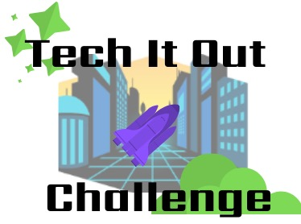
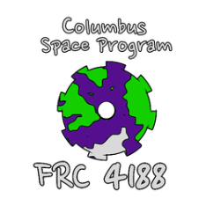
Activities for Students Attending the Columbus District FIRST Robotics Competition

February 26, 2020

The Education Committee of the Columbus District FIRST Robotics Competition welcomes you to get involved in the excitement of this year’s FIRST Robotics challenge called

FIRST is an acronym that means For Inspiration and Recognition of Science and Technology and it is the biggest STEM competition in the world that involved students from K to 12. This is the fifth time that the city of Columbus has hosted a District tournament, and we want to continue to show our community the energy of FIRST and make a positive impact on our students and teachers. It is our hope that the excitement generated will result in the expansion of FIRST into local classrooms as well as the formation of upper elementary, middle, and high school teams.
Let us show you what FIRST is about. This field trip is not meant to be a passive event – give your students some ownership of the educational opportunity. Here are some ways to do it. View the 3 minute video that introduces the challenge this year.
https://youtu.be/gmiYWTmFRVE or go to the field trip site.
The game was designed with input from “Imagineers” from the Disney Corporation and the Star Wars universe. This competition was designed for high school students supported by teachers and mentors.
Three Activities with Student Competition Component: these activities are similar to the process real FRC teams take in addressing a new game:
STRATEGY
After watching the 3 minute video, groups of 2 students can work together to complete a Strategy Plan which is a realistic description of what a robot built by a group of high school students should be able to do in 2 ½ minutes. Examples completed for previous years games linked on the website, made by students at different levels.
DESIGN/ENGINEERING
Many students are visual thinkers and learners and will see the game video and instantly imagine some mechanism that would make the robot accomplish the goals of the game. Groups of 2 students will describe and sketch mechanical solutions to parts of this year's game. This sketch does not have to be an entire robot with all of its components. Examples completed for previous years games linked here made by students at different levels.
IMAGINATION
Some students can imagine the big picture where a robot would be in midst of the competition. This competition is looking for artistic renditions of a robot or robots competing in this year’s game. Provide a picture of what a match would look like halfway through on paper no bigger than 11x14 inch.

