Battery Spill Kit
1. At competitions, send someone to inform Pit Admin about the spill.
2. Clear the area of the spill. Stay away from the spill, and make sure that as many items as fit are not near the spill.
3. The designated person to clean up the spill must have the proper equipment on (safety goggles, rubber gloves).
4. Remove the battery from the area and place in the spill kit bucket.
5. Pour baking soda on the battery spill and on the battery.
6. Clean up the area with paper towels.
7. Discard of the paper towels in the spill kit bucket.

If any substances come in contact with the skin, wash thoroughly with soap and water.

If substances come in contact with the eye, wash thoroughly with water.
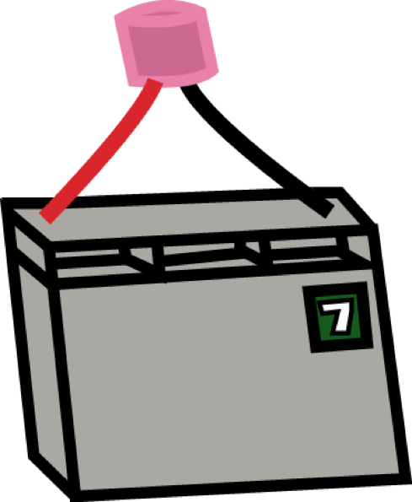
NOTE: The area is still dangerous after cleanup. Contact admin to block off the area.
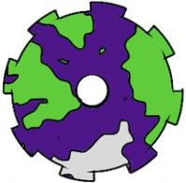
Be safe Columbus Space Program!

